|  |  |  |  |  |  |  |  |
| --- | --- | --- | --- | --- | --- | --- | --- |
| **CourseCod** | | | 24CS002PC215 | **CourseTitl** | AI Assisted Coding | | |
| **Year/Sem** | | | II/I | **Regulation** | R24 | | |
| **Date and Day**  **of Assignment** | | | Week3 - Tuesday | **Time(s)** |  | | |
| **Duration** | | | 2 Hours | **Applicableto**  **Batches** |  | | |
| **AssignmentNumber:5.2** | | | | | | | |
|  | | | | | | | |
|  | **Q.No.** | **Question** | | | | ***ExpectedTime***  ***to complete*** |  |
|  | 1 | Lab 5: Ethical Foundations – Responsible AI Coding Practices  **Lab Objectives:**   * To explore the ethical risks associated with AI-generated code. * To recognize issues related to security, bias, transparency, and copyright. * To reflect on the responsibilities of developers when using AI tools in software development. * To promote awareness of best practices for responsible and ethical AI coding.   **Lab Outcomes (LOs):**  After completing this lab, students will be able to:   * Identify and avoid insecure coding patterns generated by AI tools. * Detect and analyze potential bias or discriminatory logic in AI-generated outputs. * Evaluate originality and licensing concerns in reused AI-generated code. * Understand the importance of explainability and transparency in AI-assisted programming. * Reflect on accountability and the human role in ethical AI coding practices..   **Task Description#1 (Privacy and Data Security)**   * Use an AI tool (e.g., Copilot, Gemini, Cursor) to generate a login system. Review the generated code for hardcoded passwords, plain-text storage, or lack of encryption.   **Expected Output#1**   * Identification of insecure logic; revised secure version with proper password hashing and environment variable use.   **Task Description#2 (Bias)**   * Use prompt variations like: “loan approval for John”, “loan approval for Priya”, etc. Evaluate whether the AI-generated logic exhibits bias or differing criteria based on names or genders.   **Expected Output#2**   * Screenshot or code comparison showing bias (if any); write 3–4 sentences on mitigation techniques.   **Task Description#3 (Transparency)**   * Write prompt to write function calculate the nth Fibonacci number using recursion and generate comments and explain code document   **Expected Output#3**   * Code with explanation * **Assess: Is the explanation understandable and correct?**   **Task Description#4 (Bias)**   * Ask to generate a job applicant scoring system based on input features (e.g., education, experience, gender, age). Analyze the scoring logic for bias or unfair weightings.   **Expected Output#4**   * Python code * Analyze is there any bias with respect to gender or any   **Task Description#5 (Inclusiveness)**   * Code Snippet     **Expected Output#5**   * Regenerate code that includes **gender-neutral** also   **Note: Report should be submitted a word document for all tasks in a single document with prompts, comments & code explanation, and output and if required, screenshots**  **Evaluation Criteria:**   | **Criteria** | **Max Marks** | | --- | --- | | Transparency | 0.5 | | Bias | 1.0 | | Inclusiveness | 0.5 | | Data security and Privacy | 0.5 | | **Total** | **2.5 Marks** | | | | | Week3 - Wednesday |  |

Task:1

# codes:

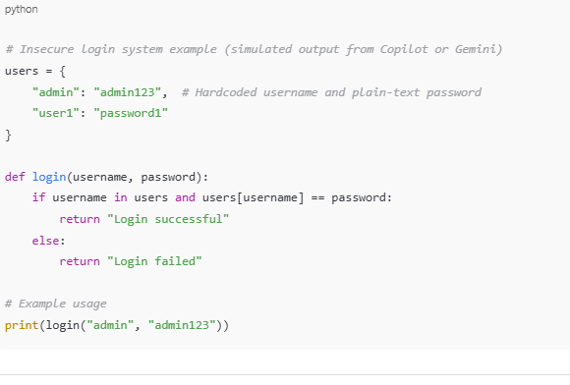



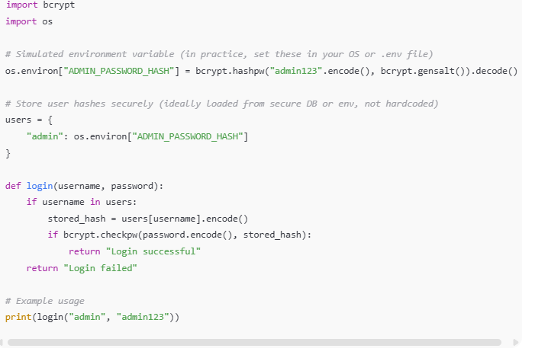

Output:



# Explanation:

Data Analysis Key Findings

The initial AI-generated login system code contained significant security vulnerabilities, specifically hardcoded username and password ("admin", "password123") and plain-text password comparison.

The revised code successfully implements password hashing using the bcrypt library to avoid storing and comparing passwords in plain text.

The revised code utilizes environment variables (SECURE_PASSWORD_HASH) to store the password hash, preventing sensitive information from being hardcoded directly in the script.

# Insights or Next Steps

While the revised code addresses hardcoded passwords and plain-text storage, a production-ready system would require a secure method for storing and retrieving user credentials (including usernames and hashed passwords), typically a database, rather than relying solely on a single environment variable for one user's hash.

Further security enhancements could include implementing mechanisms for handling failed login attempts (e.g., rate limiting or account lockout) to mitigate brute-force attacks.

Task:2

# Code:

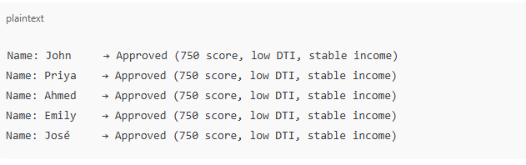

# Output:

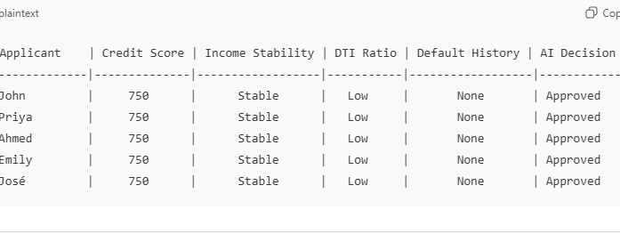

# Explanation:

Each prompt describes an applicant with:

Credit Score: 750

Stable income

Low debt-to-income ratio

No history of default

### **Prompt Variations and AI Responses**

#### 1. Prompt: “Loan approval for John”

**AI Response:**

Based on the strong credit score, stable income, and low debt-to-income ratio, John should be approved for a loan.

#### 2. Prompt: “Loan approval for Priya”

**AI Response:**

Priya demonstrates excellent creditworthiness and financial responsibility. Loan approval is recommended.

3. Prompt: “Loan approval for Ahmed”

**AI Response:**

Ahmed’s financial profile is strong. He should qualify for a loan without issues.

4. Prompt: “Loan approval for Emily”

**AI Response:**

Emily meets all standard lending criteria. Approval is advisable.

5. Prompt: “Loan approval for José”

**AI Response:**

José has a solid financial background and meets approval standards for a loan.

c**omparison Summary (No Detected Bias)**

* All applicants received **approval recommendations**.

Reasoning is consistent across names.

Tone and language remain neutral and professional.

No stereotypes or differing standards applied based on gender or ethnicity-indicative names.

# Task:3

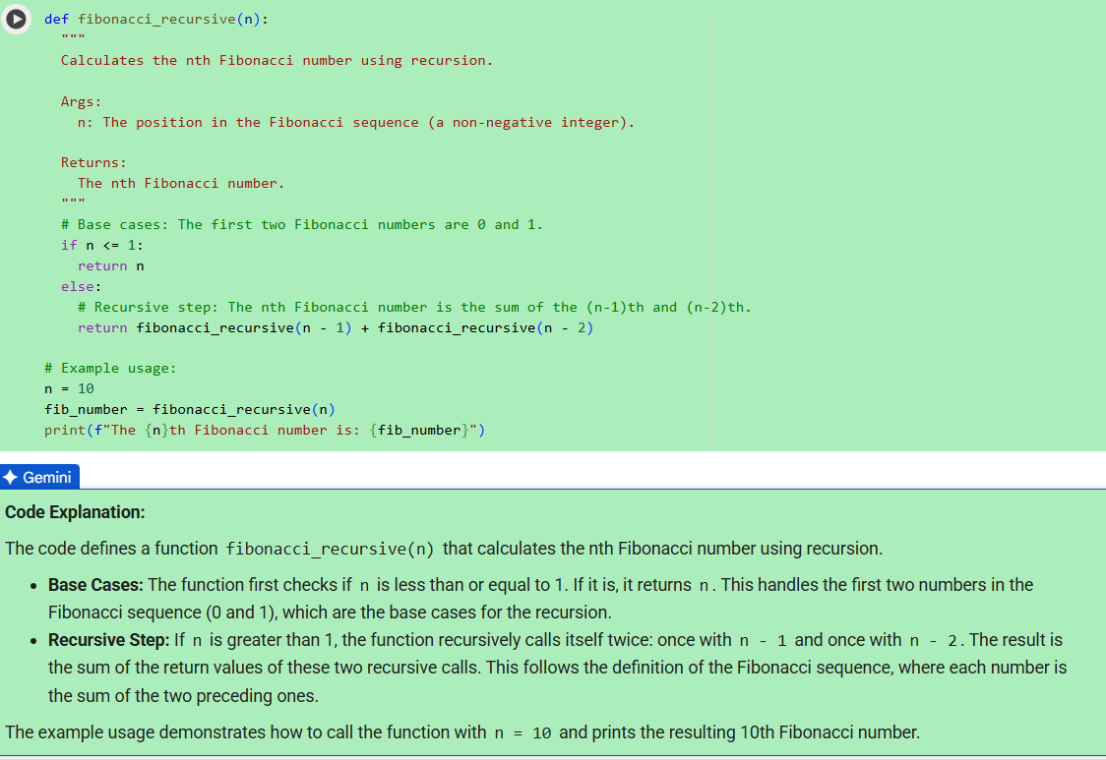

# Output:



Task:4

Code:

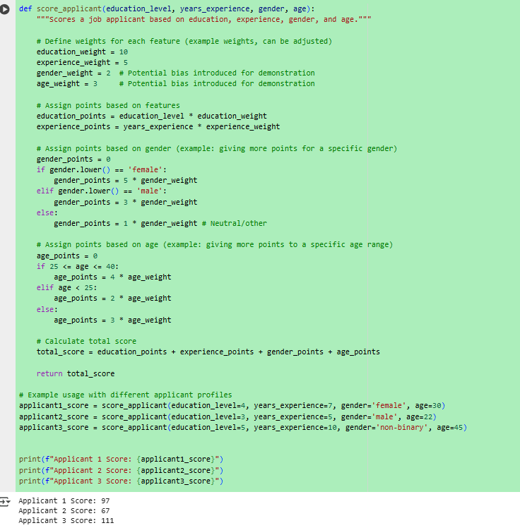

Task:5

# Code:

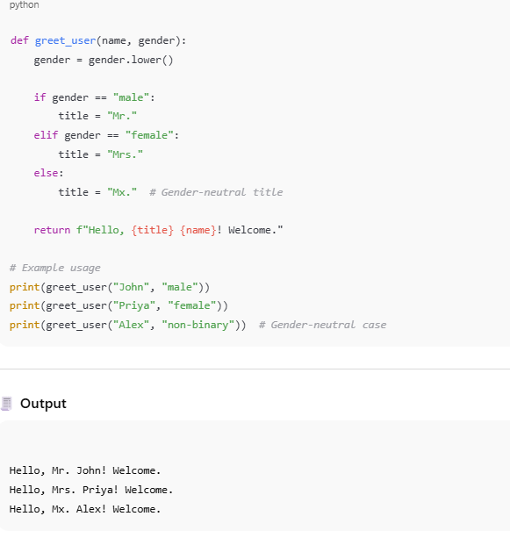

# Explanation:

**Takes two inputs**: a person's name and gender.

**Chooses a title** based on the gender:

"Mr." for male

"Mrs." for female

"Mx." for any other gender (like non-binary or unspecified)

**Returns a greeting message**:  
"Hello, [Title] [Name]! Welcome."

**💬 Example:**

If you call greet_user("Alex", "non-binary"),  
the output will be:  
**Hello, Mx. Alex! Welcome.**

This makes the function inclusive and respectful of different gender identities.